파이썬 실행코드

|  |
| --- |
| import cv2 as cv  import sys  img = cv.imread('soccer.jpg')  if img is None:  sys.exit('파일을 찾을 수 없습니다.')    BrushSiz = 5  LColor, RColor = (255, 0, 0), (0, 0, 255)  def painting(event, x, y, flags, param):  if event == cv.EVENT_LBUTTONDOWN:  cv.circle(img, (x,y), BrushSiz, LColor, -1)  elif event == cv.EVENT_RBUTTONDOWN:  cv.circle(img, (x,y), BrushSiz, RColor, -1)  elif event == cv.EVENT_MOUSEMOVE and flags == cv.EVENT_FLAG_LBUTTON:  cv.circle(img, (x,y), BrushSiz, LColor, -1)  elif event == cv.EVENT_MOUSEMOVE and flags==cv.EVENT_FLAG_RBUTTON:  cv.circle(img, (x,y), BrushSiz, RColor, -1)      cv.imshow('Painting', img)    cv.namedWindow('Painting')  cv.imshow('Painting', img)  cv.setMouseCallback('Painting', painting)  while(True):  if cv.waitKey(1)==ord('q'):  cv.destroyAllWindows()  break  elif cv.waitKey(1)==ord('+'):  if BrushSiz < 50:  BrushSiz += 1  elif cv.waitKey(1)==ord('-'):  if BrushSiz > 1:  BrushSiz -= 1 |

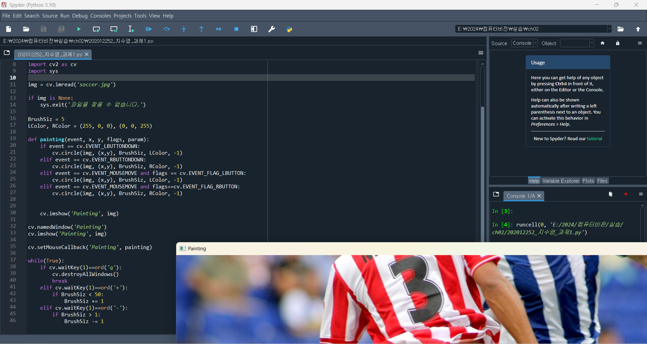

(1)

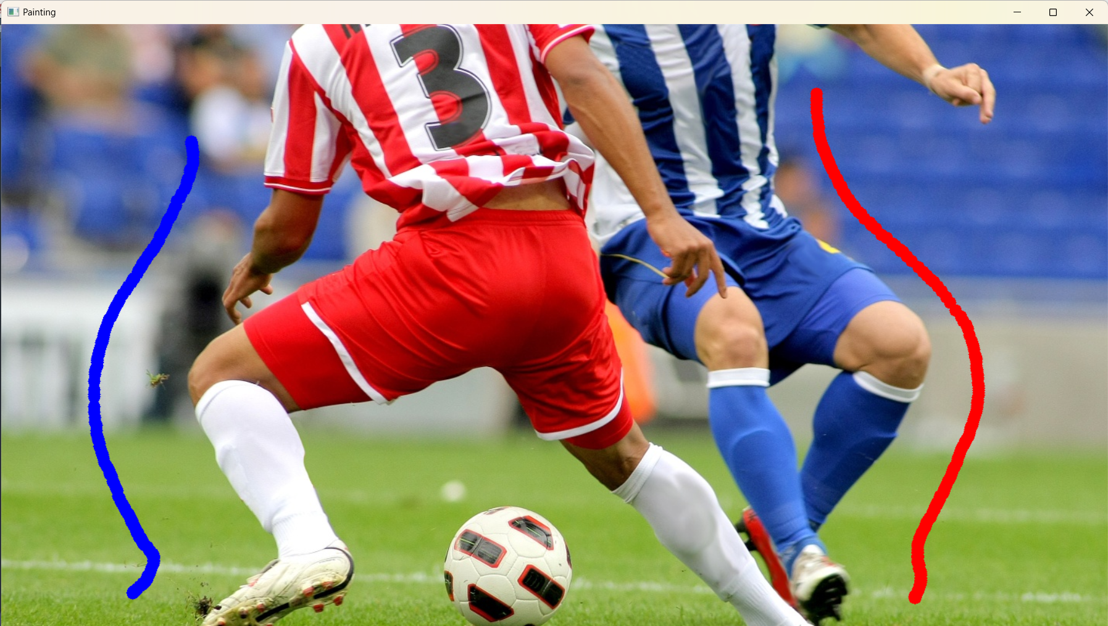

(2)

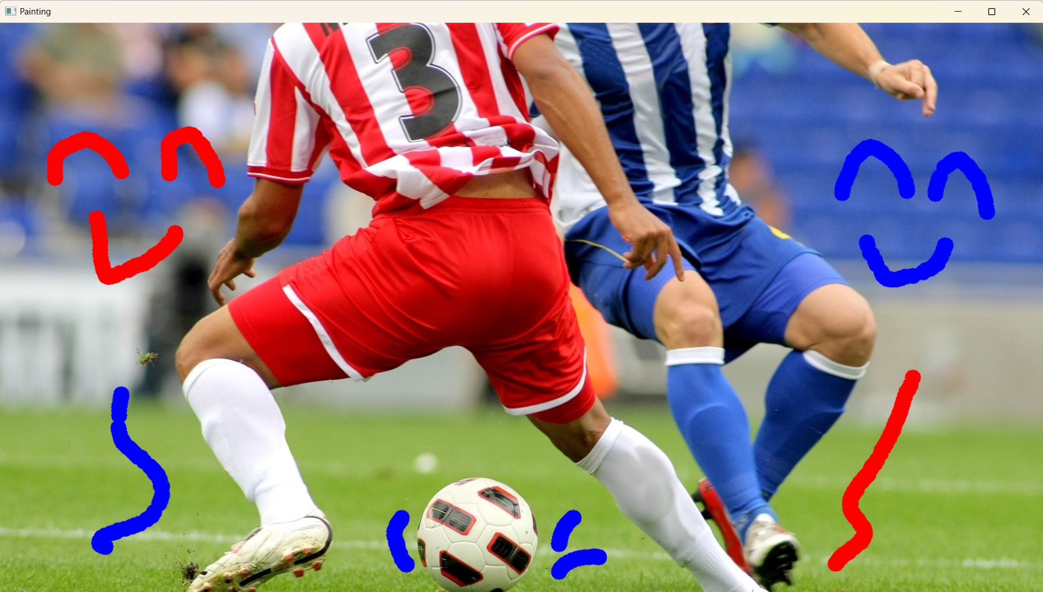

(3)

